Lab 2

**Question 1: Build APIs using MVC Asp.net**

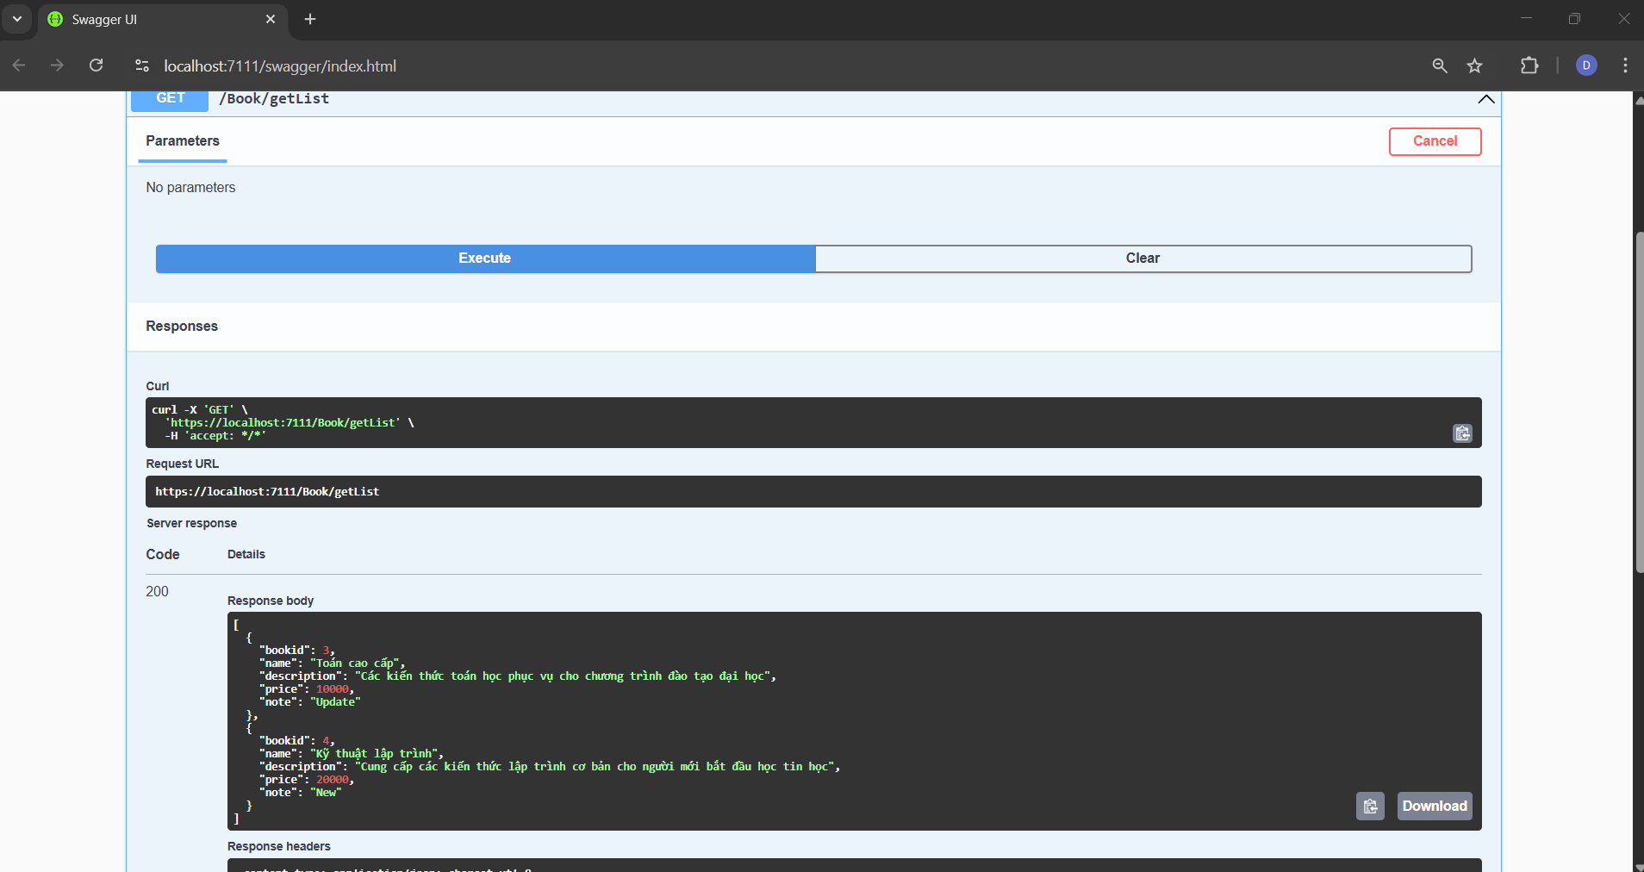

**Question 2. Build APIs using Node Js**

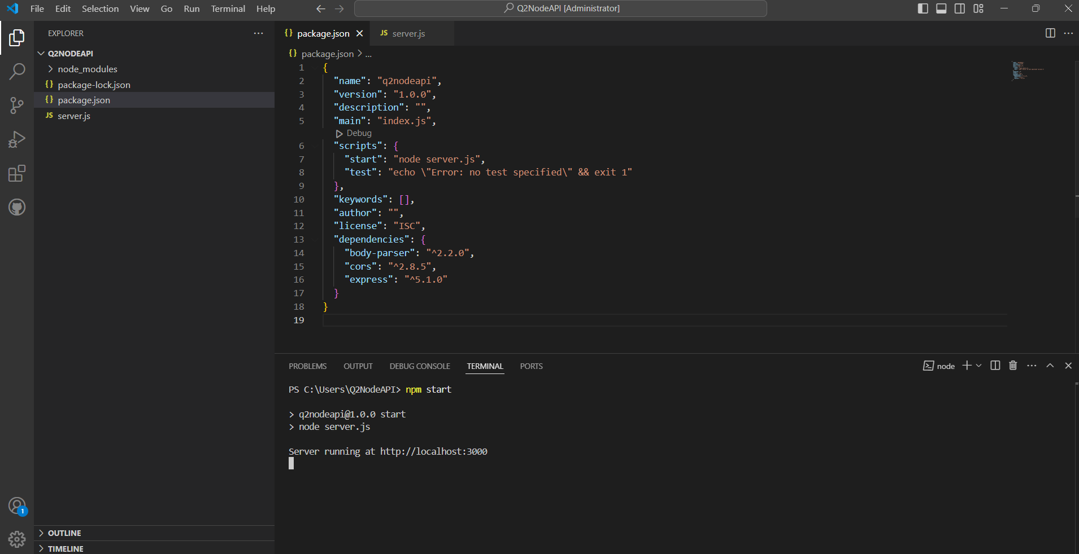

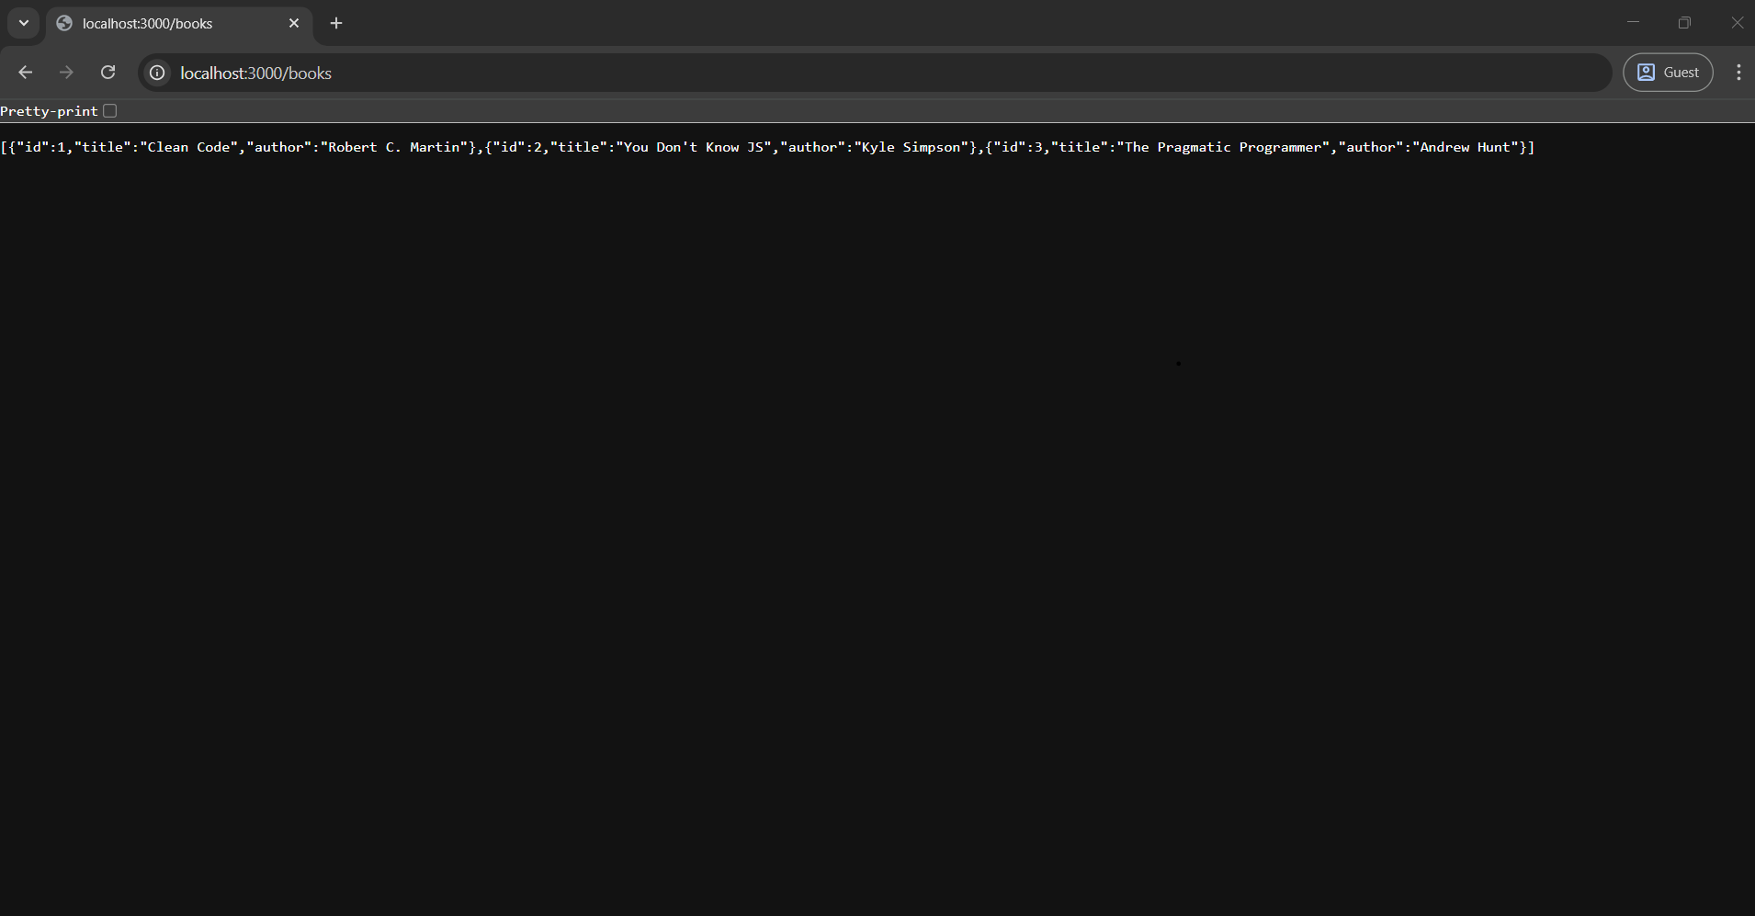

**Question 3. Login screen interface design.**

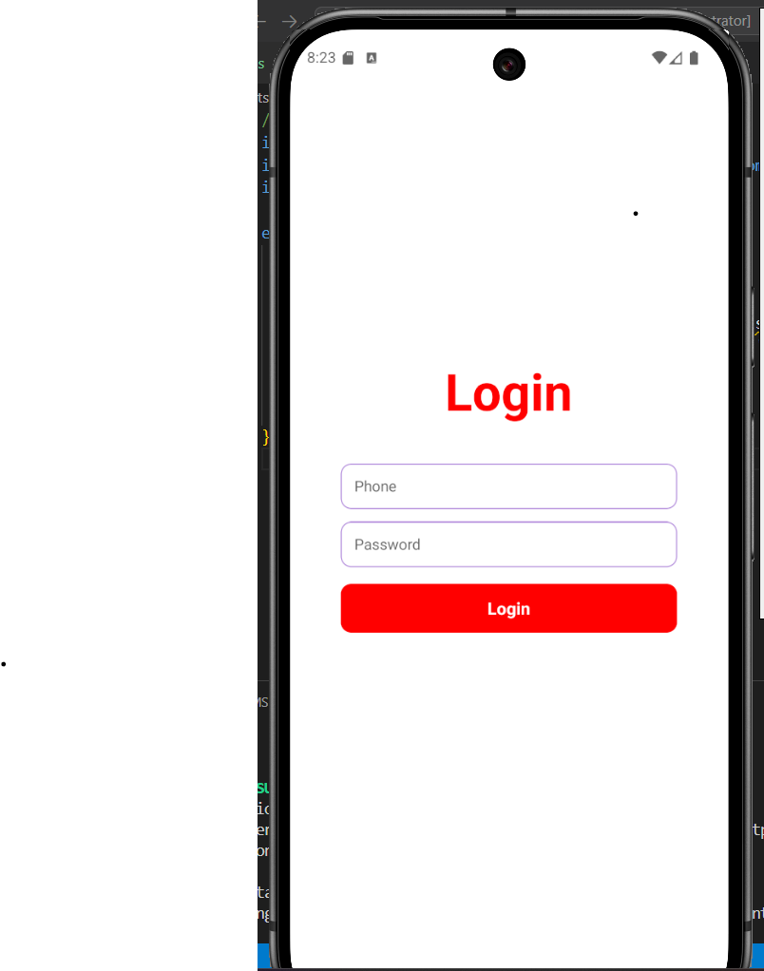

**Question 4. Write the Personal Income Tax Calculation program**

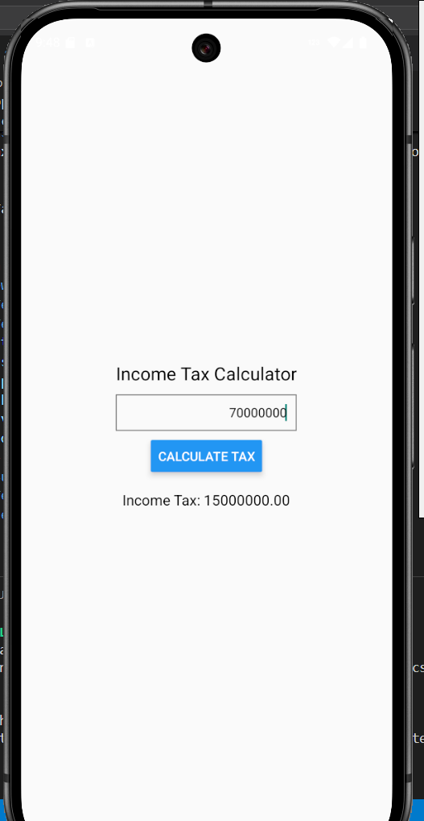

**Question 5. Caculator screen interface design**

